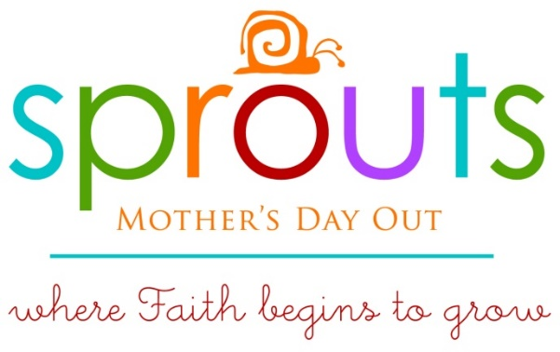

2022-2023 Calendar

September 1 Meet Your Teacher
September 6 First Day of Sprouts
November 22-24 Thanksgiving Holidays
December 15 Last day before Christmas
January 4 Sprouts Resumes
March 28-30 Spring Break
May 18 Last Day of Sprouts

